ROAD CROSSING

PROJECT REPORT



Group 12

Lưu Quốc Đoàn – 18125005

Nguyễn Trần Quang Duy – 18125048

Trần Anh Kiệt – 18125093

Contents

Chapter I. PROLOGUE 3

Chapter II. INTRODUCTION 4

2.2 Name of project 4

2.2 Purpose of project 4

Chapter III. ANALYSIS & GAME DESIGN 5

3.2 Functional requirements 5

3.2 Design the theme 6

(a) Splash screen 6

(b) Menu 6

(c) New game 7

(d) Pause and resume 7

(e) Save game 8

(f) Load game 9

Chapter IV. RESULT 10

Chapter V. REFERENCES 10

Chapter VI. CONCLUSION 10

# PROLOGUE

In this present world where we are living in, everything happens so fast that maybe someday you wake up in the morning and hear everyone talking about something, like a new fashion trend, or a newly released song, which is not even a thing the night before. The same scenario is also applied to science community, where new ideas and advancements are made every seconds passes. What considered new and modern today can be soon replaced by a better one in the future.

So why should we concern about something so far in the past, say, the Cross Road game, while just keeping up with the developing pace of the world is already not easy- you may ask?

For in science, a lot of subjects that, may be considered old-fashioned to some, still have valuable lessons lying within. Like in computer science, for example, the 23 design patterns introduced many years ago still have their appearance here and there in many of today’s technologies. Thus, to answer why we spend our valuable time on re-discovering the Cross Road, I would say:

The Cross Road game is not the final purpose of this project but, the OOP concept behind it is what worth.

# INTRODUCTION

## Name of project

The name of our project is Cross Road Game. Simply as the name has said it all, the major task and goal of the game is to “cross the road”. While crossing the road, there might appear some animals and/or vehicles that block the way. If the player collide with these obstacles, the game will end with losing of the player. In contrary, the player will win if he arrives on the other side safely.

The platform for our project is C++

## Purpose of project

The best way to learn about OOP concept is the combination of both learning the its abstract theorical concepts and applying those in practices. Acknowledging that, we have found that making Cross Road game is suitable for practicing OOP concept, for the following reasons:

Each type of objects (obstacle, player,..) has many behaviors related to it, described by functions and variables. The need of an efficient way to control all the methods related to an object is satisfied by the encapsulation, a concept in OOP.

In order to manage the obstacles (animals, vehicles, and so on), a base class is needed to control the common methods, and for polymorphism of different methods of each specific obstacles.

Another reason is that after finishing our project, the game is something we can enjoy playing too.

# ANALYSIS & GAME DESIGN

## Functional requirements

* The rule of the game is that the player must manipulate his character by pressing the button A, D, W and S to move to the left, right, upward and downward respectively.
* The player must control his character to get to the final lane without colliding with 4 lanes filled with moving objects.
* The character moving to the final lane will win and can access to higher level, which includes more objects or faster moving objects.
* Colliding with an object means game over. Then the player will be asked if he wants to restart of exit the game. By pressing the Y button, he will be able to restart the game on level 1. Choosing the ESC button allows him to exit the game.
* In the game the player will be allowed to pause or resume the game by pressing the button P and R respectively.
* Pressing the T button will pause the game and the player will be asked to name his file in order to save the current game.
* Pressing the L button will pause the game and the player will be asked to input the name of the saved file to load the old data.
* Pressing ESC button will close the game.
* While the vehicles move, there will be a traffic light which alert the player of the movement of those objects.
* The menu includes 4 choices, new game by pressing N button will create a new game for the player. Pressing the L button will ask the player to input the name of the saved file to load the old game. The S button will open the setting function, however this have not been developed so there will be a instruction that helps you get back to the menu. Pressing the E button will exit the game.

## Design the theme

### Splash screen

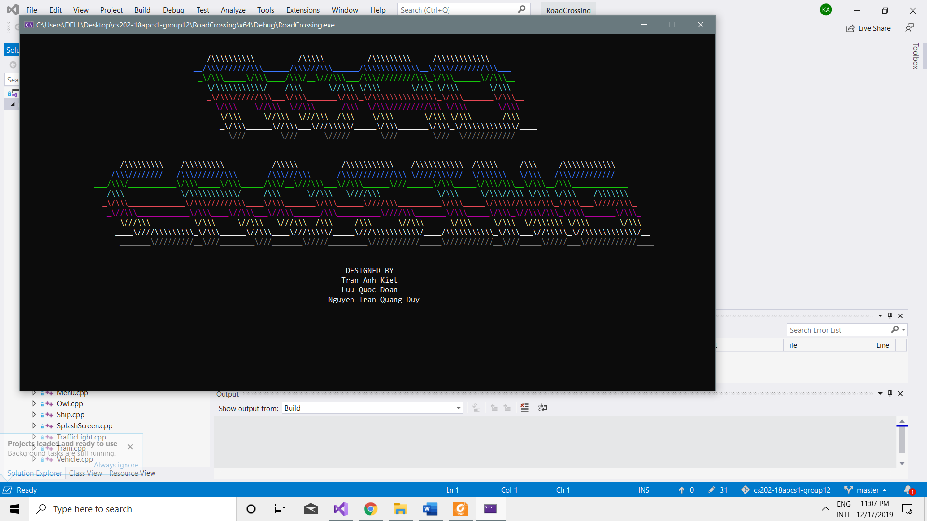

The splash screen shows the name of the game and the name of the programmers who built it.

### Menu

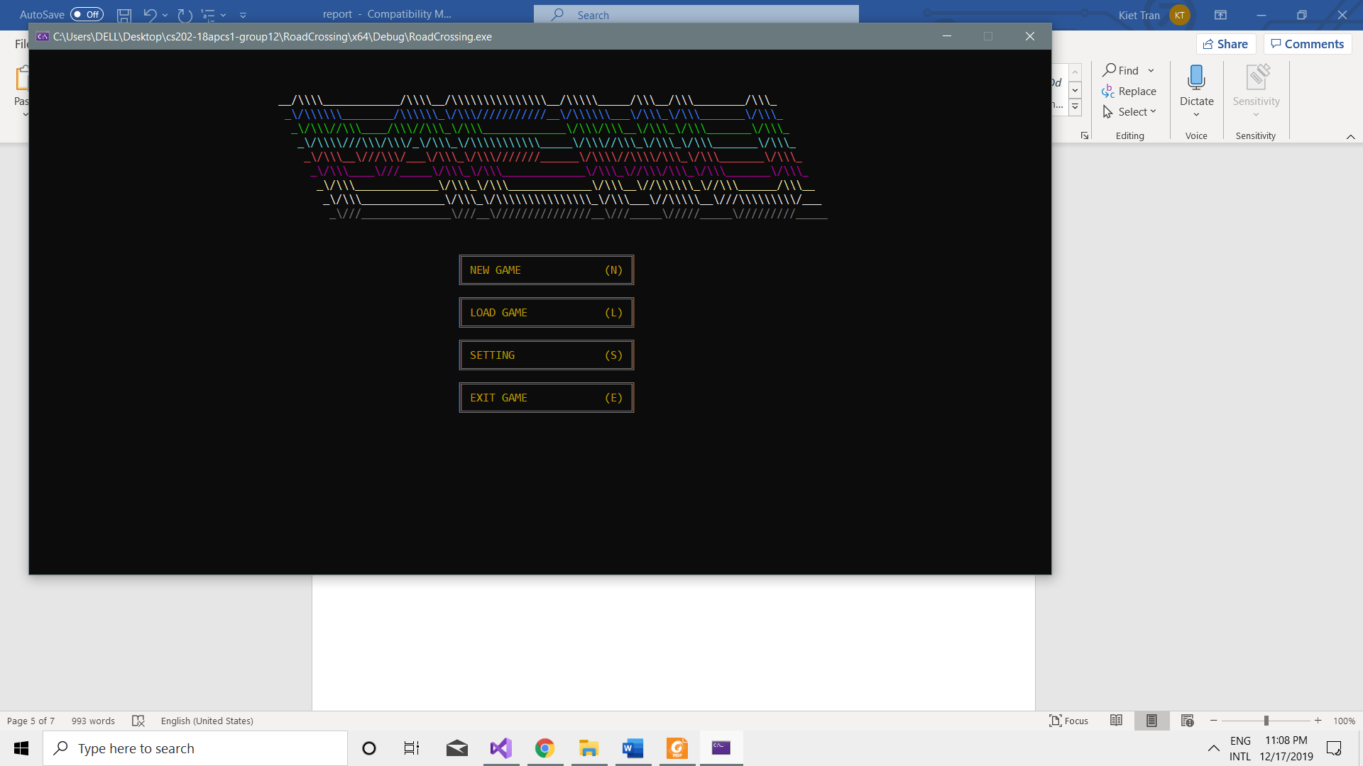

There are 4 choices for the Menu, namely new game, load game, settings and exit game.

### New game

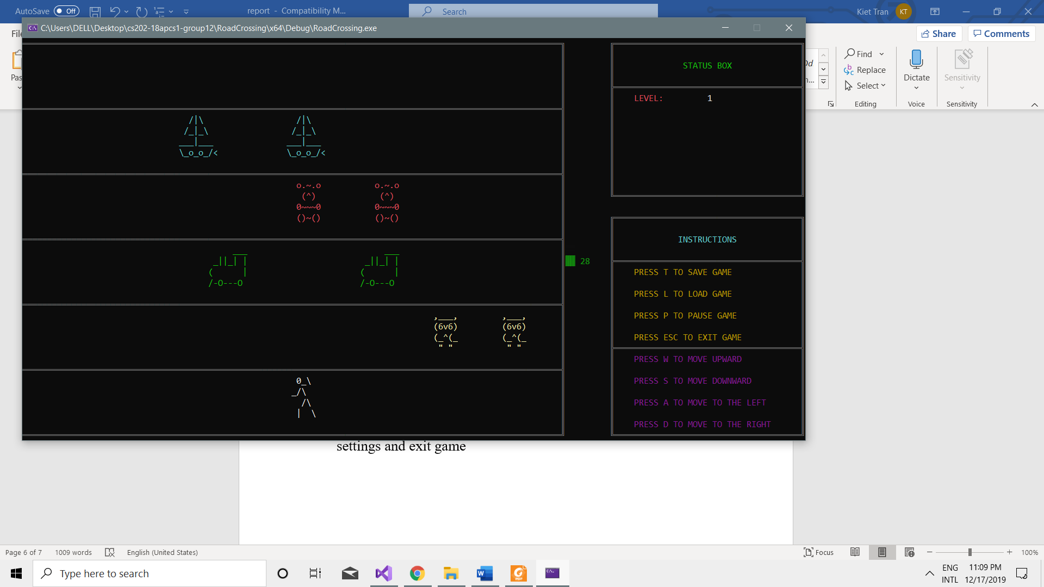

This is the main theme of the game, the biggest frame includes 6 lanes (1 starting lane, 4 lanes for moving obstacles, 1 finishing lane).

The status box indicates the level and the status of the game.

The instructions box shows the function of each button.

### Pause and resume

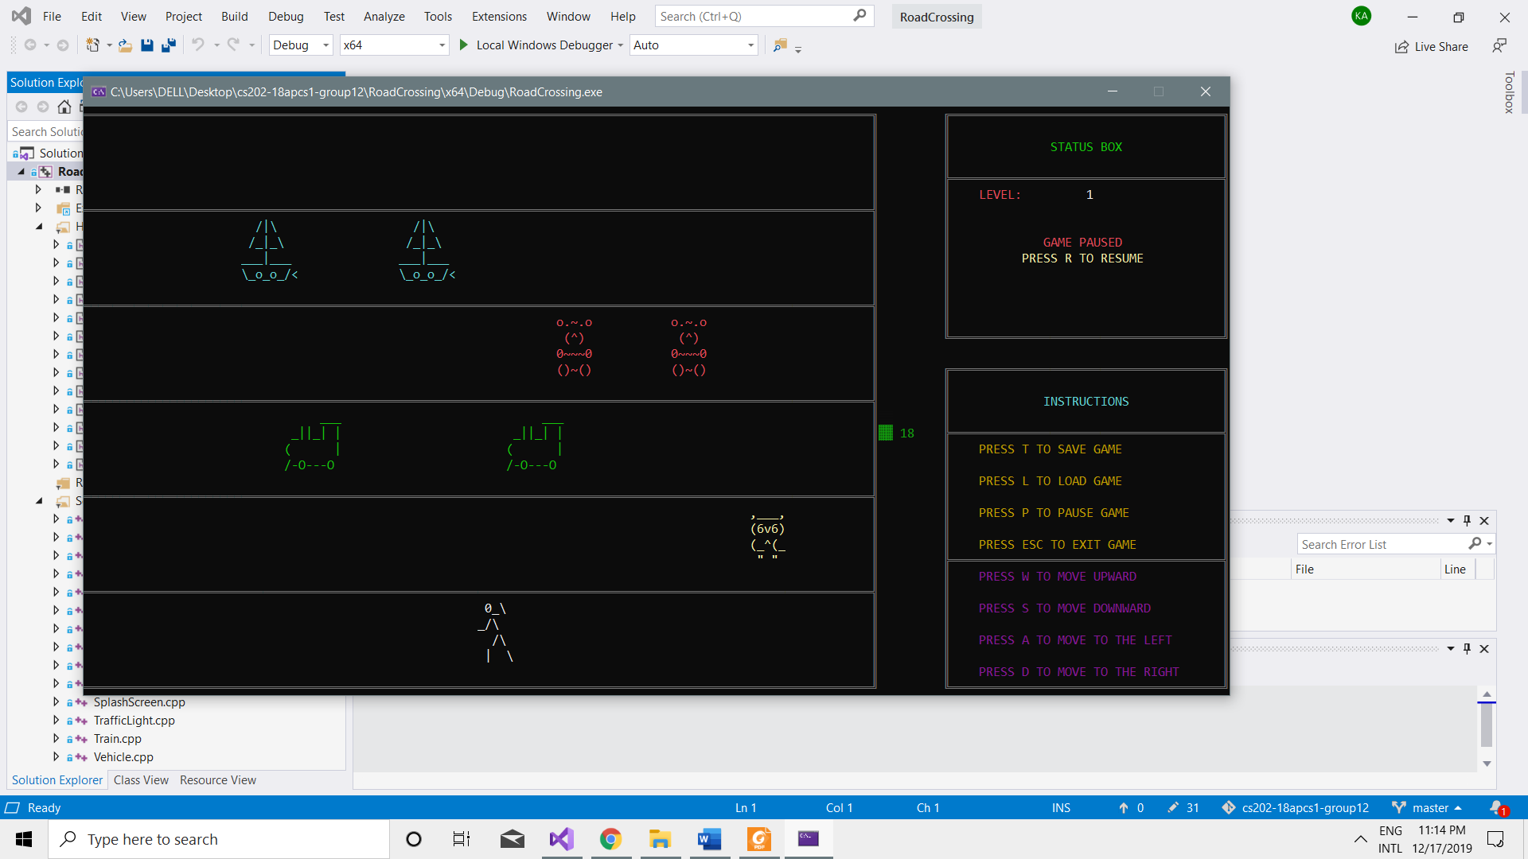

When pressing the P button all the things on the lanes will be stopped and the status is shown in the box. Pressing the R button will allow player to resume the game.

### Save game

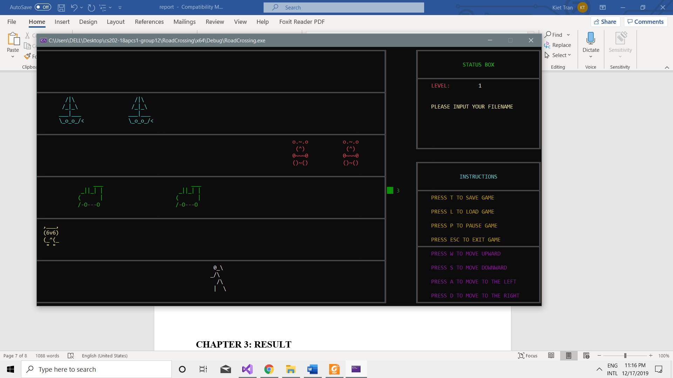

When pressing T to save game, the status box will asked you to input you file name.

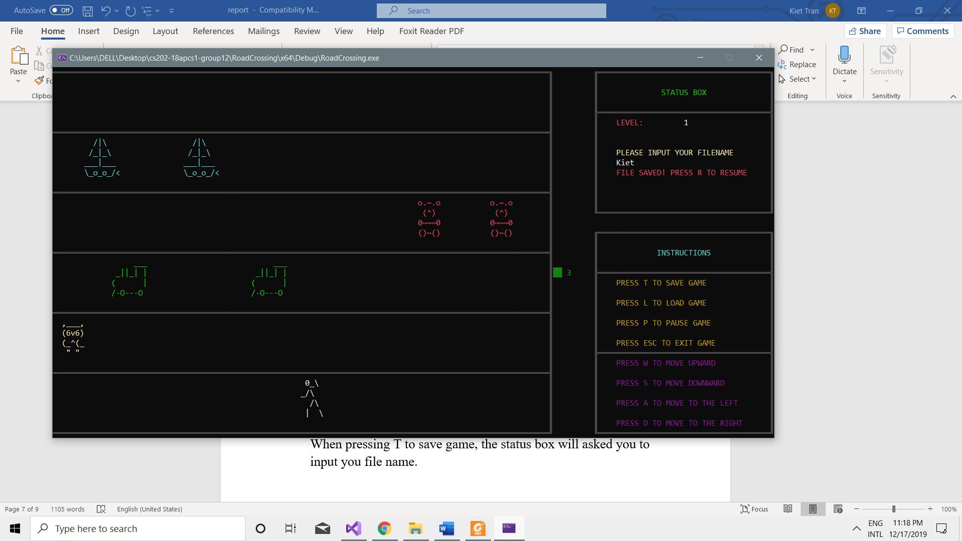

Pressing enter and R again will resume the game.

### Load game

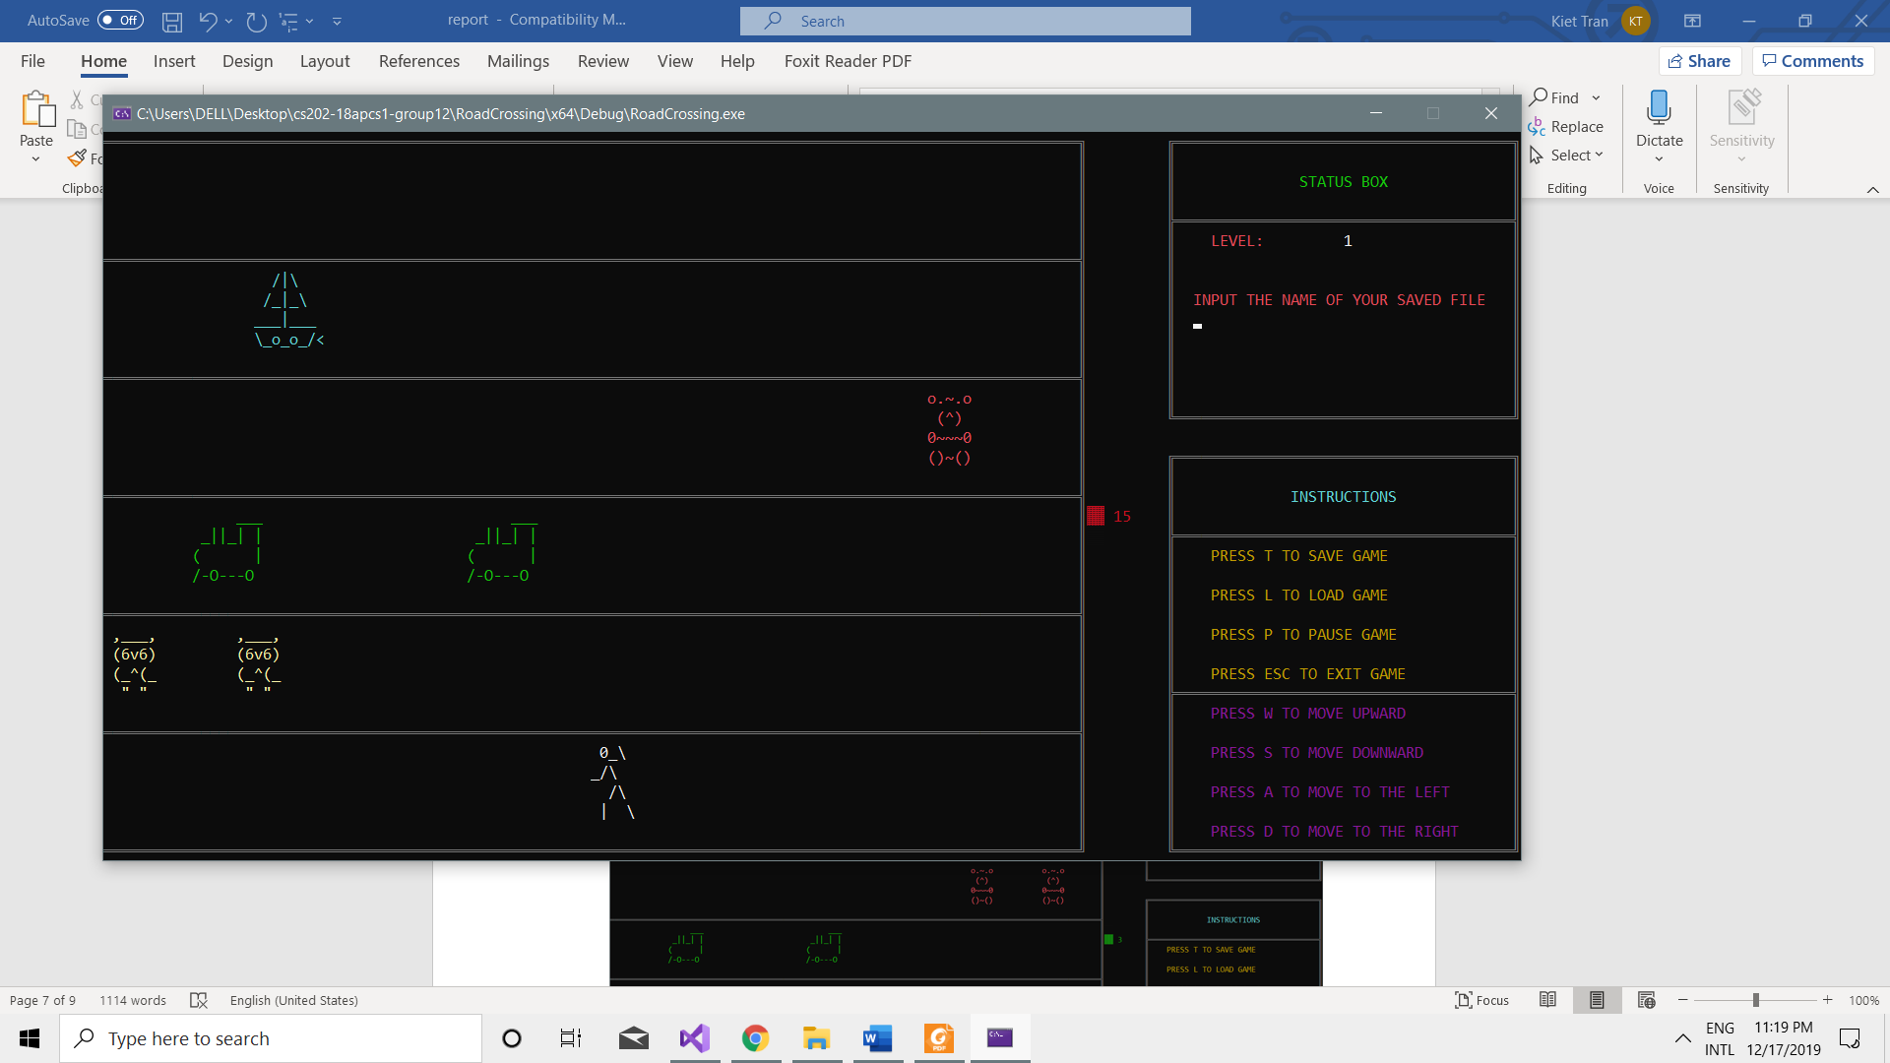

The status will ask player to input the name of the old saved file to load the data.

#### Collision

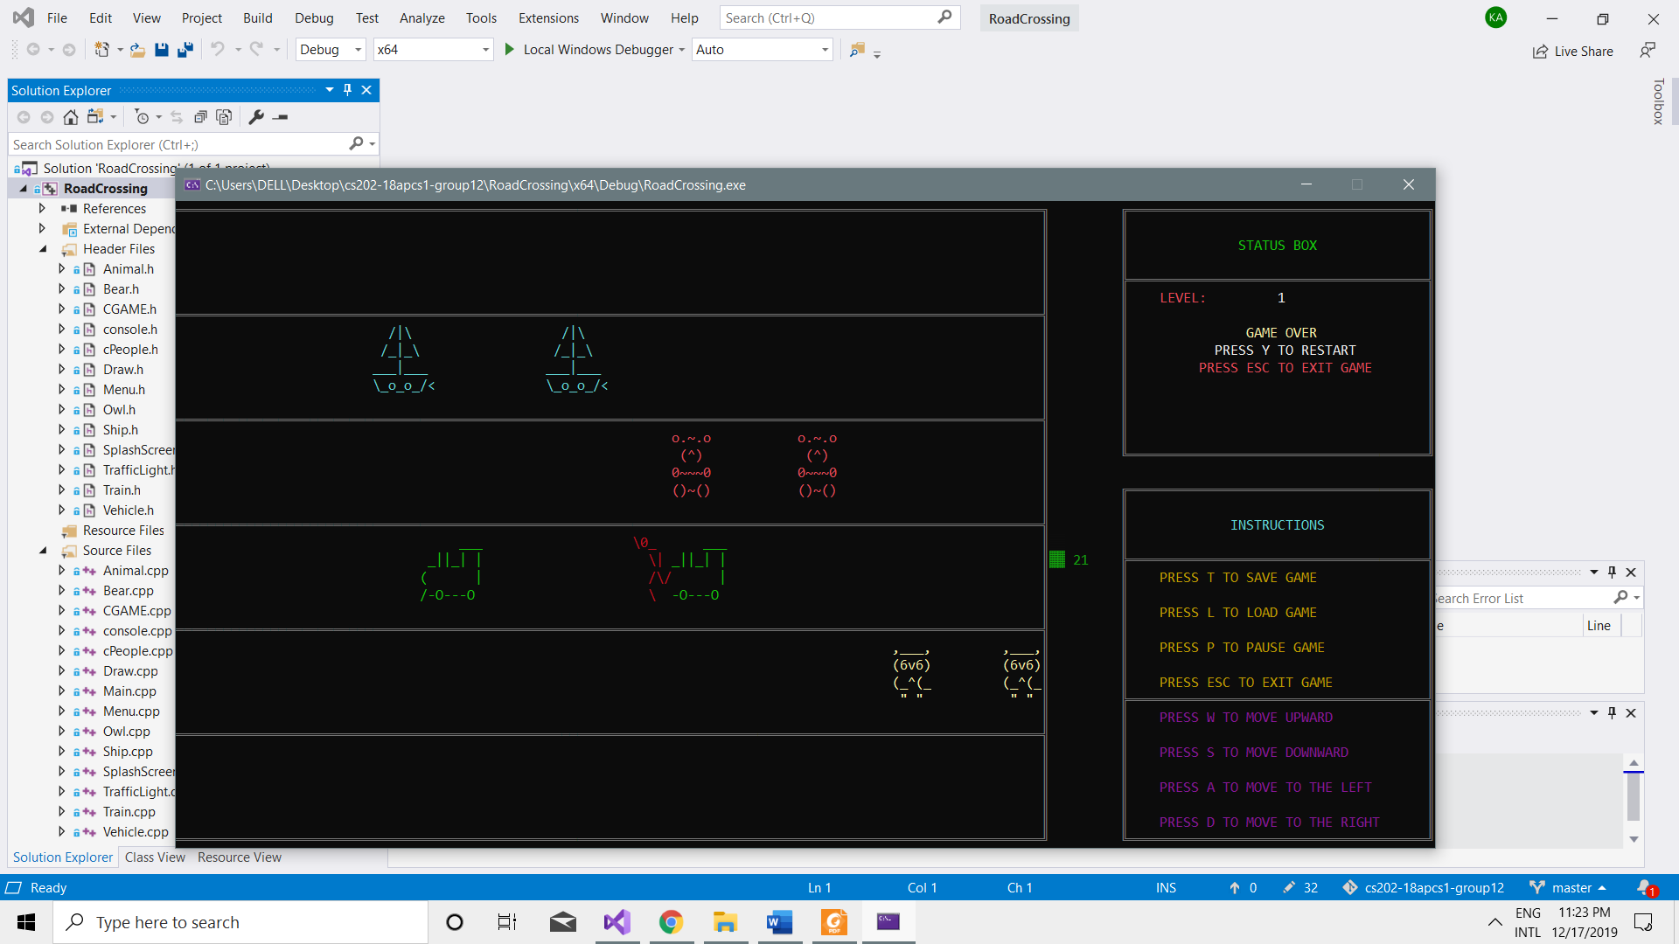

When colliding with an obstacle the character will turn red and change his posture. The status box will show the instruction to the player to follow.

# RESULT

The final project: Cross Road game will include 12 stages (levels). Each level passed the difficulty will increase a bit and randomly (varies from having more cars, or the moving speed is faster, or both).

Player is enabled to save the current progress at any time during game play and load it before beginning a new game.

There is background music add up for a more joyful gaming experience too.

# REFERENCES

* The background music Tetris Plus, Lucky Number Show, Team Rocket, Opening by 8-Bit Arcade.
* The game making tutorial <https://www.youtube.com/watch?v=C7yokRqdd4o&t=628s>
* The game making tutorial <https://www.youtube.com/watch?v=ekEDWeoBDvo&t=1237s>

# CONCLUSION

While working on this project, we have encountered many difficulties here and there. Say, the first time we worked on multi-threading was a mess, everything was out of control. But by careful research and readings we found ways to walk through all the problems.

And now, we are proud to say that, the game – this project is at its completed state and our work are paid-off. The lesson this project give is not only to practice the OOP concept, but also how to work as a team, how to detect problems and find the solution together.

Thank you for reading through our report.